Wednesday May 13th & Thursday May 14th | Activity
Math- Wednesday  Review- Solving two step word problems. In class we wrote out equations or used models. The video reflects what we did in class, but please feel free to solve it the way that best suits you. Learnzillion videos do not require a login, if you are trying to access “additional materials” then you will be asked to create a login.  https://learnzillion.com/lesson_plans/8632-solving-two-step-word-problems-using-a-model/  https://learnzillion.com/lesson_plans/5281-solve-two-step-problems-using-parentheses/  Thursday  Review- Identifying equivalent fractions using models.  https://learnzillion.com/lesson_plans/5164-identify-equivalent-fractions-using-fraction-models/ | Wednesday-  - Two step problem solving enrichment sheet (in TEAMS files)  Thursday-  - Identifying equivalent fractions using models (in TEAMS files)  Learnzillion shouldn’t be asking you for a login. If it gives you issues you can find great, helpful videos on Khan Academy, you just need to search for addition and subtraction videos.
ELA (Writing and Grammar) | Optional Assignments  A to Z Memory Book (in the TEAMS files)  Or  Covid-19 Time Capsule (in TEAMS files)
Social Studies  Entrepreneurship | Wednesday-  - Watch “Entrepreneur” (Episode 3) https://www.cha-chingusa.org/videos  - Complete “I Can with a Plan” business plan challenge (on page 8 in the file on TEAMS), pages 9 and 10 have ideas if you are stuck.  - The page you will be working on looks like:  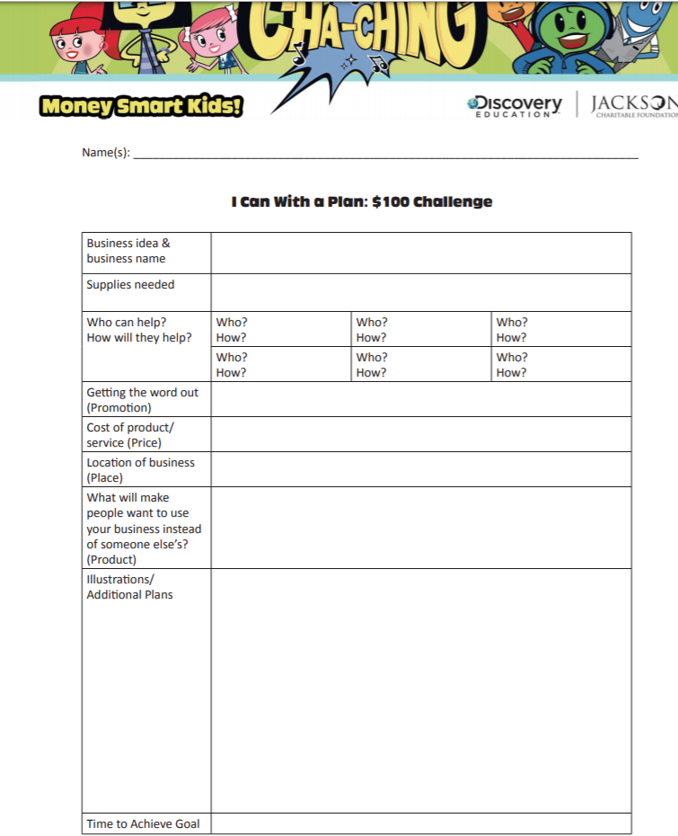  Thursday  - TEAMS meeting @10am to share our business plans! Can’t wait to see what you have come up with!
Reading | Wednesday  - Virtual field trip with “I Survived” author Lauren Tarshis  http://www.scholastic.com/beyondthebattlefield/  Thursday  - “Marvel Themed Trivia Celebration” This is for the new book “Shuri” from the Blank Panther series. The event takes place at 2pm.  https://kids.scholastic.com/kids/games/homebase/bookfest/

