Wednesday, April 22nd | Activity
Math  Volume will be taught through Khan Academy | - Login to Khan Academy  - Complete Volume activities (there are 5 total)  Khan Academy items are Due Friday
ELA  Materials can also be found on TEAMS under “files” and then “class materials”  We will have another meeting on Thursday to check in with how planning has gone and planning the next steps. Meeting link will be sent in TEAMS in the “posts” section.  Meeting will be at 10am Thursday. | - Complete BOTH planning sheets (both sheets are on the Weebly page)  - The Plot “mountain”  - The Comic Strip planning sheet
Science | Keep working on your PSA or infographic if you haven’t finished.
Reading  Materials can also be found on TEAMS under “files” and then “class materials”  Meeting link is in TEAMS in the “posts” link.  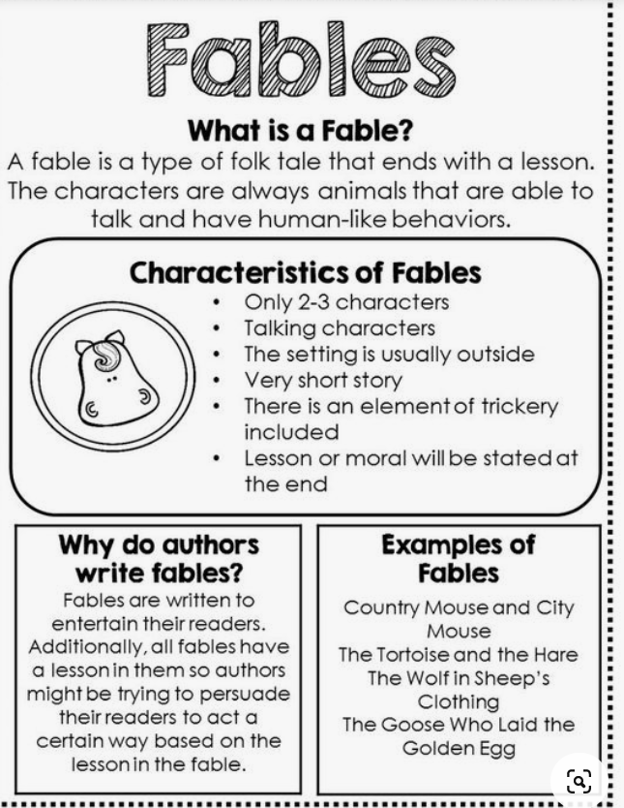 | - Our lesson will actually be on Wednesday at 10am through TEAMS. Here is what you need to do before the meeting:  - Watch “Theme” video on Brain Pop Jr.  - Read the TWO fables  - “The Tortoise and the Baboon”  - “How the Coyote Stole Fire”  - You need to have the compare and contrast organizer preprinted and ready to go. We will fill it out together during our TEAMS meeting.

