Wednesday, April 1st. | Activity
Math  No new activity today | Zearn (only if you have time)- If your agenda is at school and you need your login, let me know.  Practice multiplication facts if you don’t know them. You need to know 0-10 by the end of the year.
ELA | Login to earn your VERBS badge in Grammaropolis (on your teacher’s Clever page)  Once you complete a unit with a 75% or better I can Dojo you a certificate  Only do if you haven’t completed yet.  Complete 1 activity from the fictional writing choice board (Found on Weebly page).  Due Friday.
Social Studies (All students in my class)  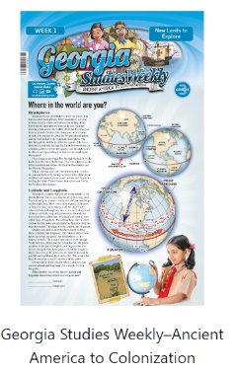  This is what the third-grade edition looks like. | Go to Studies Weekly (in Clever on my teacher page)  You will be working with Week 18 “More Southern Colonies”  Read:  - “At Last”  - “Slavery in the Colonies”  - “Primary Sources-Auctions and Escapes of Enslaved People”- Complete the activity that goes with this article.
Reading  You will need to login to Newsela (available on Clever-possibly your teacher’s page)  Class Code- 69FS54 | Read the assignment “How to Build a Fixed Pulley”  Complete the quiz and the short writing prompt.

