Tuesday, April 14th | Activity
Math  Today you are working on problem solving with mass. The math is simple. It recommends using a tape diagram.  Tape Diagram Example:  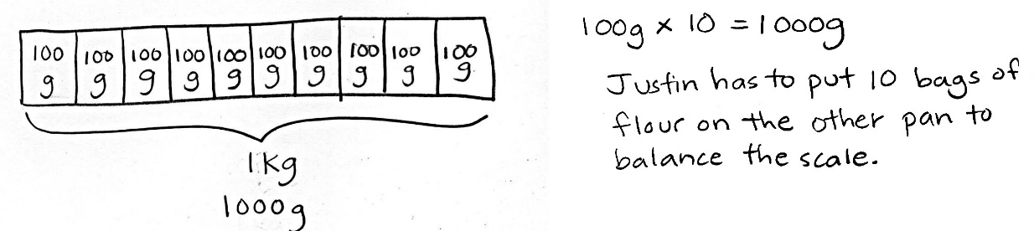  You don’t have to use this strategy, use whatever is most comfortable and what gets you the correct answer. | - Work on the problems on the following page.  - Zearn  - Practice multiplication facts
ELA | Continue working on adjective badge in Grammaropolis.
Science (All students in my class)  Login into Nearpod (my teacher page on Clever)  Activity code: CJGRN | We will meet to go through a live lesson on Nearpod at 10:15am. We will not meet through TEAMS, but we will be able to interact through the activity. Please plan on logging into the activity at 10:15am. I’ve never done a live Nearpod before, but we will see how it goes.  The title of the activity is “Human Impact”  To do the lesson with us, you will need to join with the activity code.  Don’t stress if you are unable to log on or if there are technical issues. I can always reset it if needed so you can go back on your own.
Reading  Have students go to www.readworks.org/student  Students enter class code 7TAB3V  Students find their names | Don’t forget to complete your passage.

Math Assignment
1. Use tape diagrams to model the following problems. Keiko and her brother Jiro get weighed at the doctor’s office. Keiko weighs 35 kilograms, and Jiro weighs 43 kilograms.
a. What is Keiko and Jiro’s total weight?

Keiko and Jiro weigh __________ kilograms.
b. How much heavier is Jiro than Keiko?

Jiro is __________ kilograms heavier than Keiko.

2. Jared estimates that his houseplant is as heavy as a 5-kilogram bowling ball. Draw a tape diagram to estimate the weight of 3 houseplants.

Continue to the next page….
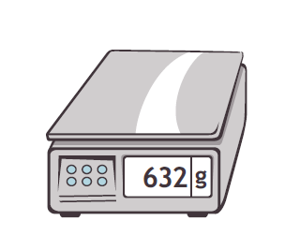
3. Jane and her 8 friends go apple picking. They share what they pick equally. The total weight of the apples they pick is shown to the right.
27 kg
- About how many kilograms of apples will Jane take home?

- Jane estimates that a pumpkin weighs about as much as her share of the apples. About how much do 7 pumpkins weigh altogether?

