Thursday, April 2st. | Activity
Math  Login to Khan Academy (you set this up, Mrs. Wnek does not have your login) | Complete all perimeter and area activities assigned.  Zearn (only if you have time)- If your agenda is at school and you need your login, let me know.  Practice multiplication facts if you don’t know them. You need to know 0-10 by the end of the year.
ELA | You don’t have any new assignments. Work on anything you haven’t completed so far. You can refer to the previous weeks for what the assignments were.
Science (All students in my homeroom)  We are beginning our conservation unit. Yay!! | We will meet on Friday at 10:00am to kick-off Spring Break and to officially launch our science unit. You will need to review the following BEFORE the meeting Friday. We will complete a graphic organizer together; we will not go back to the video or the article during the meeting.  Please review the following 3 things:  - The photo on the next page. Think about the “Questions to Consider.”  - TED Talk about the effects of air pollution, the video is a little over 12 minutes and you can read the transcripts if you need to. Complete the video notetaking sheet as you watch the video, have it ready for Friday’s meeting (sheet is on Weebly)  https://www.ted.com/talks/maria_neira_this_is_your_brain_on_air_pollution?utm_campaign=tedspread&utm_medium=referral&utm_source=tedcomshare  - The Newsela article titled, “Pollution.” The article will be on my Weebly page.
Reading

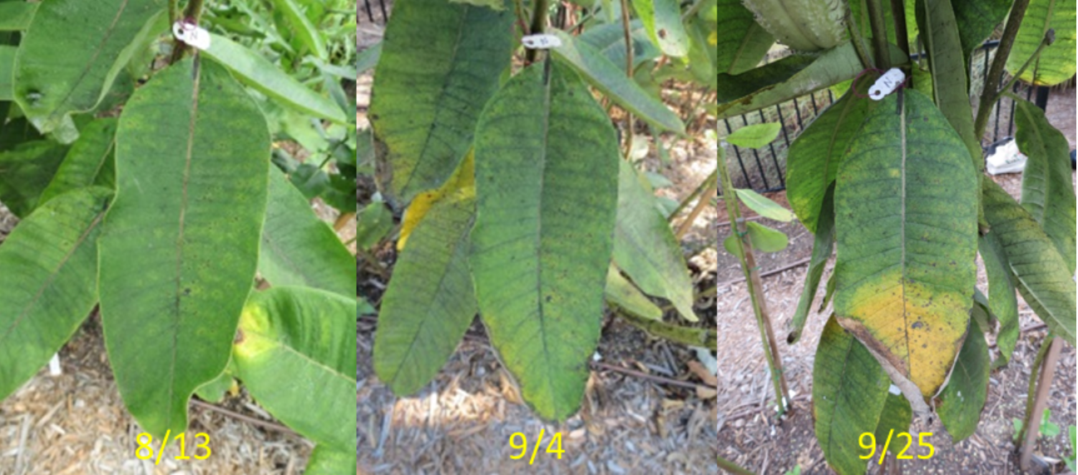

Questions to consider:
- What is happening in this photo?

- What do you think are some reasons/causes to create the change?

